9.96: Each side has length a and mass 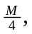 and the moment of inertia of each side about an axis perpendicular to the side and through its center is 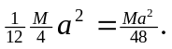 The moment of inertia of each side about the axis through the center of the square is, from the perpendicular axis theorem, 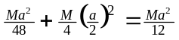. The total moment of inertia is the sum of the contributions from the four sides, or 